AUTOMATED UNIVERSITY TIMETABLE GENERATION SYSTEM USING CONSTRAINT PROGRAMMING: A CASE STUDY OF TUM
BRIAN MOTARI BSIT/533J/2021

SUPERVISOR:PROF GAVUNA

RESEARCH PROJECT SUBMITTED IN PARTIAL FULFILLMENT FOR THE DEGREE IN BACHELOR OF TECHNOLOGY IN INFORMATION COMMUNICATION TECHNOLOGY OF TECHNICAL UNIVERSITY OF MOMBASA

JAN 2026

DECLARATION
This project is my original work and has not been presented for a degree in any other University or for any other award.
Student’s Name: __________________________ Sign: __________ Date: __________

I confirm that the work reported in this project was carried out by the candidate under my supervision.
Name: __________________________ Sign: __________ Date: __________

DEDICATION
To my parents, for their relentless support and encouragement throughout my academic journey, and to the faculty for their guidance.

ACKNOWLEDGEMENT
I wish to express my sincere gratitude to my supervisor for their invaluable guidance and constructive criticism throughout the development of this proposal. I also acknowledge the Institute of Computing and Informatics at the Technical University of Mombasa for providing the necessary resources to undertake this study. Finally, I thank my colleagues and family for their patience and moral support during this research process.

ABSTRACT
The process of generating university timetables is a complex combinatorial problem characterized by numerous constraints such as room capacity, lecturer availability, and course clashes. Currently, the Technical University of Mombasa relies on semi-automated methods that are time-consuming and prone to human error, often resulting in scheduling conflicts. The purpose of this study is to design and develop an Automated University Timetable Generation System harnessing Constraint Programming (CP) to solve these scheduling conflicts efficiently. The study focuses on optimizing resource allocation within the university. The methodology adopted is the Agile development approach, utilizing an iterative design to refine constraints and objectives, with Java chosen as the implementation language due to its robust ecosystem. The expected findings include a significant reduction in scheduling time and the elimination of hard constraint violations, such as double-booking of rooms or lecturers. This system will serve as a vital tool for academic registrars, ensuring accurate and efficient utilization of university infrastructure.

TABLE OF CONTENTS

LIST OF TABLES
Table 3.1: Target Population.................................................................................... 10
Table 3.2: Database Schema..................................................................................... 12

LIST OF FIGURES
Figure 2.1: Conceptual Framework............................................................................ 8
Figure 3.1: Use Case Diagram................................................................................... 11
Figure 3.2: System Flowchart.................................................................................... 12

LIST OF ACRONYMS AND ABBREVIATIONS
CP: Constraint Programming
CSP: Constraint Satisfaction Problem
TUM: Technical University of Mombasa
UML: Unified Modeling Language
IDE: Integrated Development Environment
SQL: Structured Query Language

DEFINITION OF KEY TERMS
Constraint: A restriction or rule that limits the possible values a variable can take in the scheduling process.
Hard Constraint: A mandatory rule that must be satisfied for the timetable to be valid (e.g., a lecturer cannot be in two places at once).
Soft Constraint: A preference that should be satisfied as much as possible but is not mandatory (e.g., avoiding Friday afternoon classes).

CHAPTER ONE: INTRODUCTION

1.1 Introduction This chapter provides an overview of the research study. It outlines the background of university timetabling, the specific problems associated with current methods, and the objectives this research seeks to achieve using constraint programming. It also details the significance, scope, and limitations of the study.
1.2 Background of the Study University course timetabling is a classic scheduling problem that involves assigning a set of events (lectures, labs) to a set of resources (classrooms, time slots) while satisfying various constraints. As universities grow in student population and course diversity, the complexity of this task increases exponentially. Constraint Programming (CP) has emerged as a powerful paradigm for solving such combinatorial problems by defining relations between variables. Unlike traditional imperative programming, CP focuses on the "what" rather than the "how," allowing the solver to explore the search space efficiently. This study proposes a solution leveraging the Java ecosystem to automate this process, ensuring valid and optimized schedules.
1.3 Problem Statement The current timetabling process at the Technical University of Mombasa often faces challenges due to manual or semi-manual scheduling methods. Schedulers struggle to balance "hard constraints" (e.g., room capacity) and "soft constraints" (e.g., lecturer preferences). This results in delayed release of timetables, frequent clashes during the semester, and suboptimal use of room capacities. There is a missing link in employing a robust, locally adapted system that utilizes constraint programming to automatically detect and resolve these conflicts before publication.
1.4 Objectives of Study
1.4.1 General Objective The main objective of this study is to design and develop an Automated University Timetable Generation System using Constraint Programming to optimize course scheduling and resource allocation.
1.4.2 Specific Objectives (i) To analyze the existing timetabling processes and identify key hard and soft constraints. (ii) To design a constraint model representing the university's scheduling requirements using Unified Modeling Language (UML). (iii) To implement a timetable generation algorithm using a Java-based Constraint Solver. (iv) To validate the system's performance by comparing the generated schedule against historical manual timetables.
1.5 Research Questions (i) What are the critical hard and soft constraints affecting the current timetabling process? (ii) How can a constraint satisfaction model be designed to accurately represent university resources and rules? (iii) To what extent can a Java-based constraint solver automate the generation of conflict-free schedules? (iv) How does the automated system compare to manual methods in terms of time efficiency and conflict reduction?
1.6 Significance of the Study The study will primarily benefit the University Academic Registrar and departmental timetablers by significantly reducing the time spent on drafting schedules. It will also benefit students and lecturers by minimizing schedule clashes. Furthermore, the source code and logic will contribute to the academic field of applied constraint programming.
1.7 Scope of the Study The study is limited to the development of a timetable generator for the Technical University of Mombasa. It covers the scheduling of lectures and allocating rooms based on capacity. It focuses on the internal logic of constraint satisfaction and the backend implementation using Java. The geographical scope is the TUM main campus.
1.8 Limitations of the Study The study may be limited by the dynamic nature of departmental requirements, where sudden changes in curriculum or staff availability might occur. Additionally, the computational power required to solve extremely large constraint datasets could be a limitation. These limitations will be mitigated by using efficient heuristics.
1.9 Organization of the Study Chapter One introduces the study. Chapter Two reviews relevant literature. Chapter Three details the methodology. Chapter Four (to be completed later) will present findings, and Chapter Five will offer conclusions.

CHAPTER TWO: LITERATURE REVIEW
2.1 Introduction
This chapter reviews the theoretical foundations of the timetabling problem and Constraint Satisfaction Problems (CSPs). It analyzes existing systems and identifies the research gap that this project intends to fill.
2.2 Theoretical Literature
The University Timetabling Problem (UTP) is theoretically classified as an NP-complete problem. This implies that no known algorithm can solve it in polynomial time for all cases. The theoretical framework for this study is Constraint Satisfaction Problems (CSP). A CSP is defined by a set of variables, a set of domains for those variables, and a set of constraints that restrict the values variables can take. By modeling the timetable as a CSP, we can utilize search algorithms (like backtracking or local search) to find a solution that satisfies all hard constraints.
2.3 Similar Systems
Several systems exist for timetabling:
- ASC Timetables: A commercial desktop application widely used in high schools. It is effective but requires paid licenses and may not integrate easily with custom university databases.
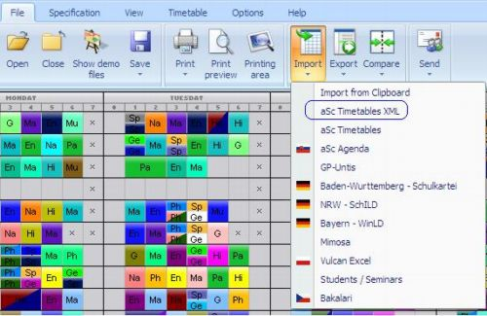
- FET (Free Timetabling Software): An open-source tool that uses genetic algorithms. While powerful, its user interface is complex for non-technical staff.
- Unitime: An enterprise-level university scheduling system. It is comprehensive but requires significant server infrastructure.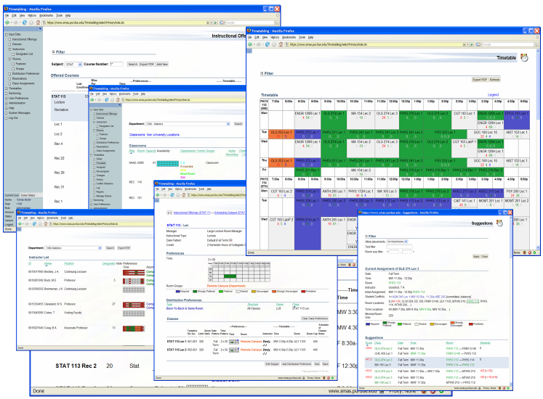
- Google Calendar (Manual): Many departments rely on manual entry, which lacks conflict detection logic.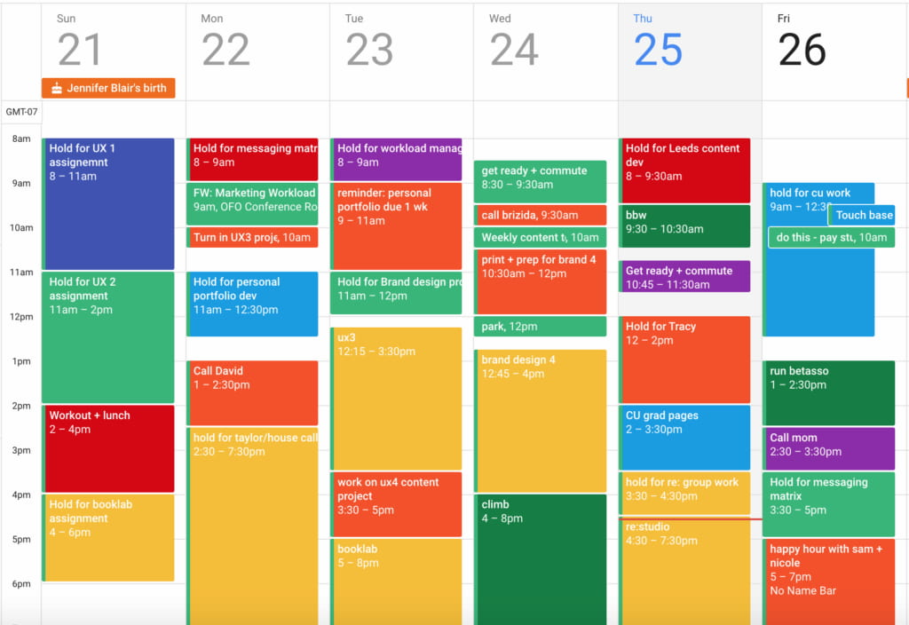
- Microsoft Excel: The most common manual tool. It offers zero automation or constraint checking, leading to human error.
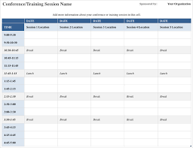
2.4 Critical Review and Research Gap Identification
While systems like FET and Unitime exist, they are often "one-size-fits-all" solutions that can be difficult to customize for specific local university policies (e.g., specific block-release schedules). Most commercial tools are closed-source. This project fills the gap by developing a modular, Java-based system specifically designed to handle the nuances of the local university context using modern Constraint Programming libraries.
2.5 Chapter Summary
This chapter reviewed the complexity of UTP and the CSP framework. It highlighted that while commercial solutions exist, there is a need for a flexible, custom solution that balances automation with local constraint requirements.

CHAPTER THREE: METHODOLOGY
3.1 Introduction
This chapter describes the research design, data collection methods, and the software development methodology used to build the system. It outlines the requirements analysis and the modeling of the system.

3.2 Research Design
This study employs an Applied Research Design. It focuses on solving a specific, practical problem ,generating a valid timetable, by applying established theories of Constraint Programming to create a functional software artifact.
3.2.1 Target Population
The target population includes the Academic Registrar staff, Departmental Timetabling Officers, and a sample of Lecturers at TUM.
3.2.2 Sample Size
A purposive sample of 3 timetabling officers and 10 lecturers will be consulted to define the constraint rules.
3.2.3 Data Collection Procedure & Instruments
Data regarding room capacities, course lists, and scheduling rules will be collected using:
- Interviews: To understand the "soft constraints" (preferences) of the staff.
- Document Analysis: Reviewing past timetables to identify common conflict patterns.

3.3 System Development Methodology
The system will be developed using the Agile Methodology. This allows for iterative development where the constraint model is built, tested, and refined repeatedly.
3.3.1 Methodology Justification: Timetabling rules are often complex and subject to change. Agile allows for continuous feedback from the user to tune the solver's parameters.

3.4 System Requirement Analysis 3.4.1 Functional Requirements
- The system must allow input of rooms, units, and lecturers.
- The system must generate a conflict-free timetable automatically.
- The system must allow manual adjustments to the generated schedule.
3.4.2 Non-Functional Requirements
- Performance: The solver should generate a schedule within 5 minutes for a standard dataset.
- Reliability: The system must ensure zero hard-constraint violations.
3.4.3 Unified Modeling Language (UML)
3.4.2.1 Use Case Modeling: A Use Case diagram will be designed to visualize actors (Admin, User) and their interactions (Manage Data, Generate Timetable). 3.4.2.2 Activity Diagram: This will illustrate the flow from data entry to constraint solving and result export. 3.4.2.3 Class Diagram: This will define the object structure, including classes for Lesson, Room, and Timeslot.

3.5 Database Design
3.5.1 Table Design:
Key tables include Lecturers, Units, Rooms, and Timeslots.
3.5.2 3NF Normalized Form:
All tables will be normalized to the Third Normal Form to reduce redundancy.

3.6 Testing Design
The system will undergo Unit Testing (for constraint logic) and User Acceptance Testing (UAT) (verified by timetabling officers) to justify usability.

3.7 Chapter Summary
This chapter outlined the agile approach for development, the specific functional requirements, and the UML models that will guide the implementation of the constraint-based system.

REFERENCES
Burke, E. K., & Petrovic, S. (2002). Recent research directions in automated timetabling. European Journal of Operational Research, 140(2), 266-280.

Schaerf, A. (1999). A survey of automated timetabling. Artificial Intelligence Review, 13(2), 87-127.
Zhang, D., & Lau, H. C. (2005). A constraint programming approach for the university timetabling problem. In Proceedings of the 5th International Conference on Practice and Theory of Automated Timetabling.

